Monthly Performance Report – July 2025
Kestrel Ridge Wind Farm (75.6 MW)
David Chen · 09 August 2025 · KR-OPS-RPT-2025-07

1. Summary
Kestrel Ridge generated 10.3 GWh in July 2025, 5.5 % below the P50 budget of 10.9 GWh. Availability of 97.3 % met the contract target of 97.0 %. Mean hub-height wind speed of 6.4 m/s was close to the long-term mean (6.6 m/s). Compared with July 2024 (10.3 GWh), output was up 0.0 GWh.

2. Production and key figures
KPI | July 2025 | Budget / target | YTD 2025 | YTD budget
Net generation (GWh) | 10.3 | 10.9 | 115.0 | 121.0
Time-based availability | 97.3 % | 97.0 % | 97.3 % | 97.0 %
Capacity factor | 18.3 % | 19.4 % | 29.9 % | –
Mean wind speed at hub height (m/s) | 6.4 | 6.6 | – | –
Source: Kestrel Ridge SCADA, revenue meter at 132 kV point of connection. Budget = P50 (2024 post-construction yield assessment).
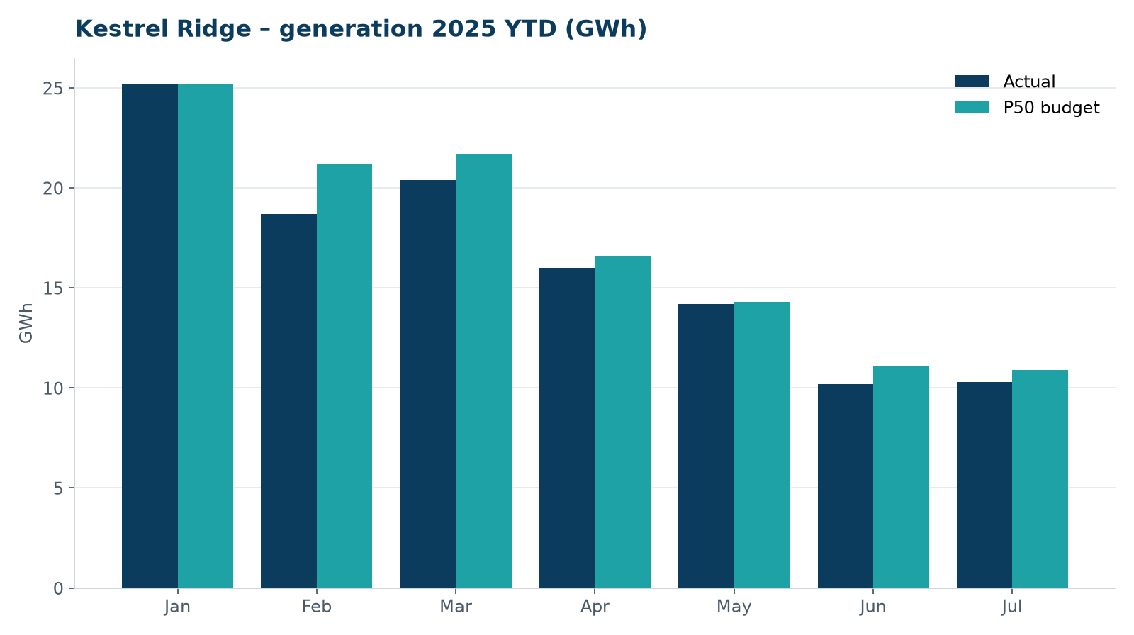
Monthly generation vs. P50 budget, 2025 year to date

3. Availability and downtime
Total turbine downtime attributable to the contractor amounted to 49 turbine-hours for the top events listed below. No grid or force majeure exclusions were claimed this month.
Turbine | Event | Downtime (h)
T-04 | converter fault – IGBT module replaced | 25
T-09 | pitch motor encoder fault on blade C | 8
T-04 | tower base controller communication loss | 7
T-17 | tower base controller communication loss | 5
T-11 | anemometer heater failure – sensor replaced | 4
Top downtime events of the month (SCADA event log, reviewed with Highline Wind Services).

4. Maintenance
- Annual service: 4 turbines completed this month.
- 22 corrective work orders closed, 2 still open at month end.
- Monthly safety equipment checks (fall arrest, rescue kits, fire extinguishers) completed on all towers.

5. Health, safety and environment
Indicator | Month
Hours worked on site (Highline + Weyland) | 4,797
Lost time injuries | 0
First aid cases | 1
Near misses reported | 1
Safety observations | 14
Environmental incidents | 0

No environmental incidents. Bird carcass searches were carried out on schedule (fortnightly, all turbines).

6. Outlook
We will review the downtime events above with Highline in the monthly O&M meeting and track the recurring pitch faults.
Prepared by Sara Lindgren (Performance Analyst); reviewed by Ben Okoye (Site Manager) and David Chen (Asset Operations Manager).

